Download AutoIt

Link: <https://www.autoitscript.com/site/autoit/downloads/>

Open auto it

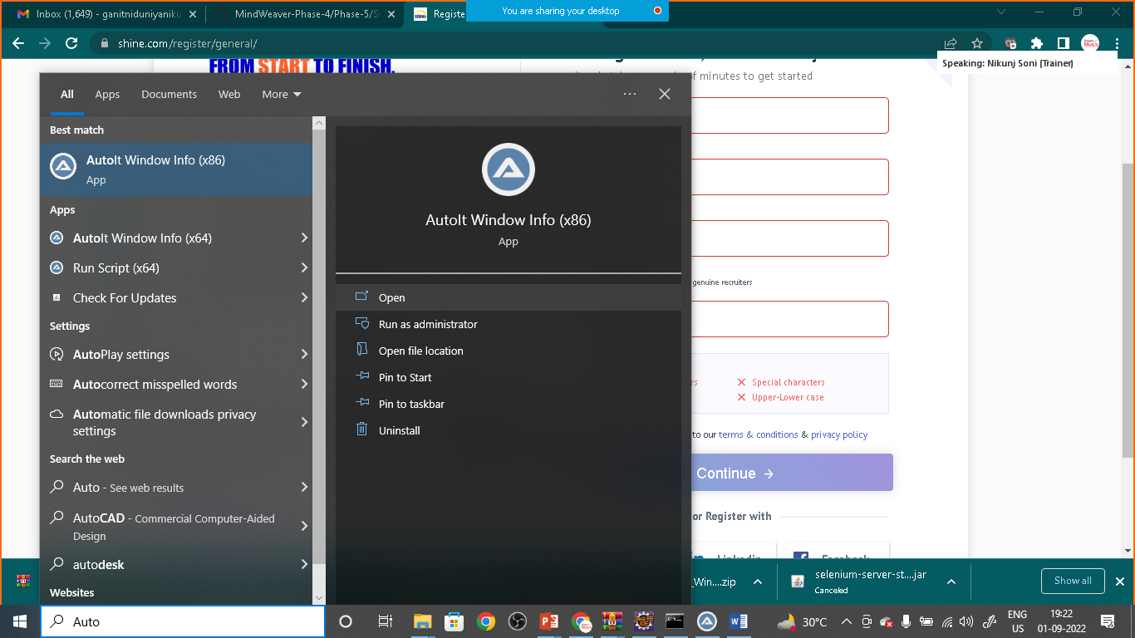

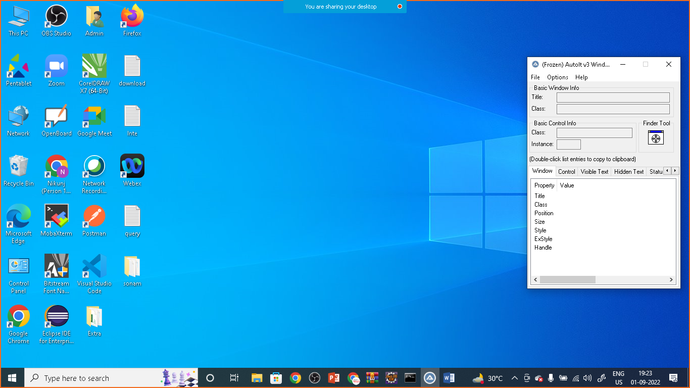

Drag and drop finder tool on Edit three things

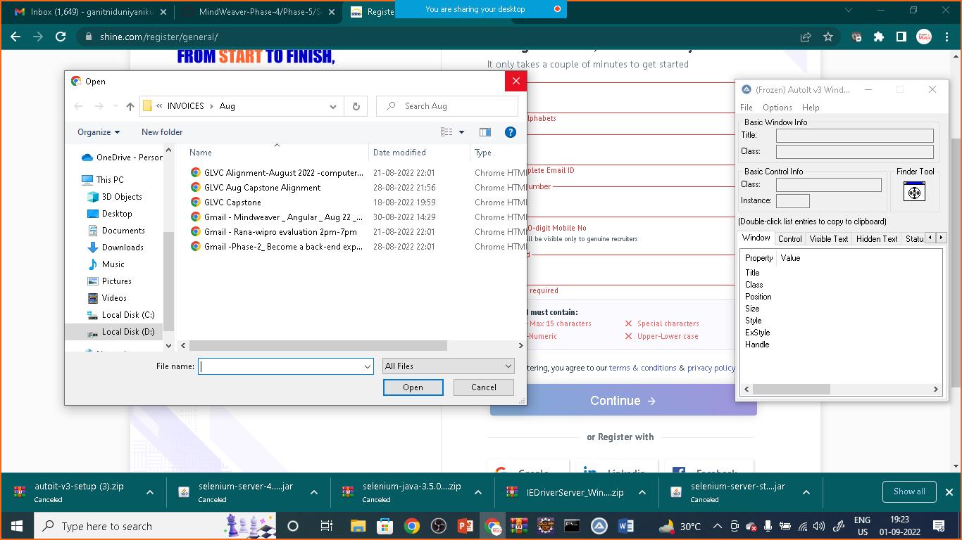

**ONCE YOU WILL DRAG AND DROP TO THE FILE NAME**

NOTE DOWN THREE THING

**TITLE:**Open

**CLASS:** Edit

**INSTANCE:**1

**AGAIN DRAG AND DROP FINDER TOOL TO OPEN BUTTON**

NOTE DOWN THREE THING

**TITLE:**Open

**CLASS:** Button

**INSTANCE:**1

Now we will use this details to write windows automation script

Goto> C:\Program Files (x86)\AutoIt3\SciTE

Click on SciTE

And write the script

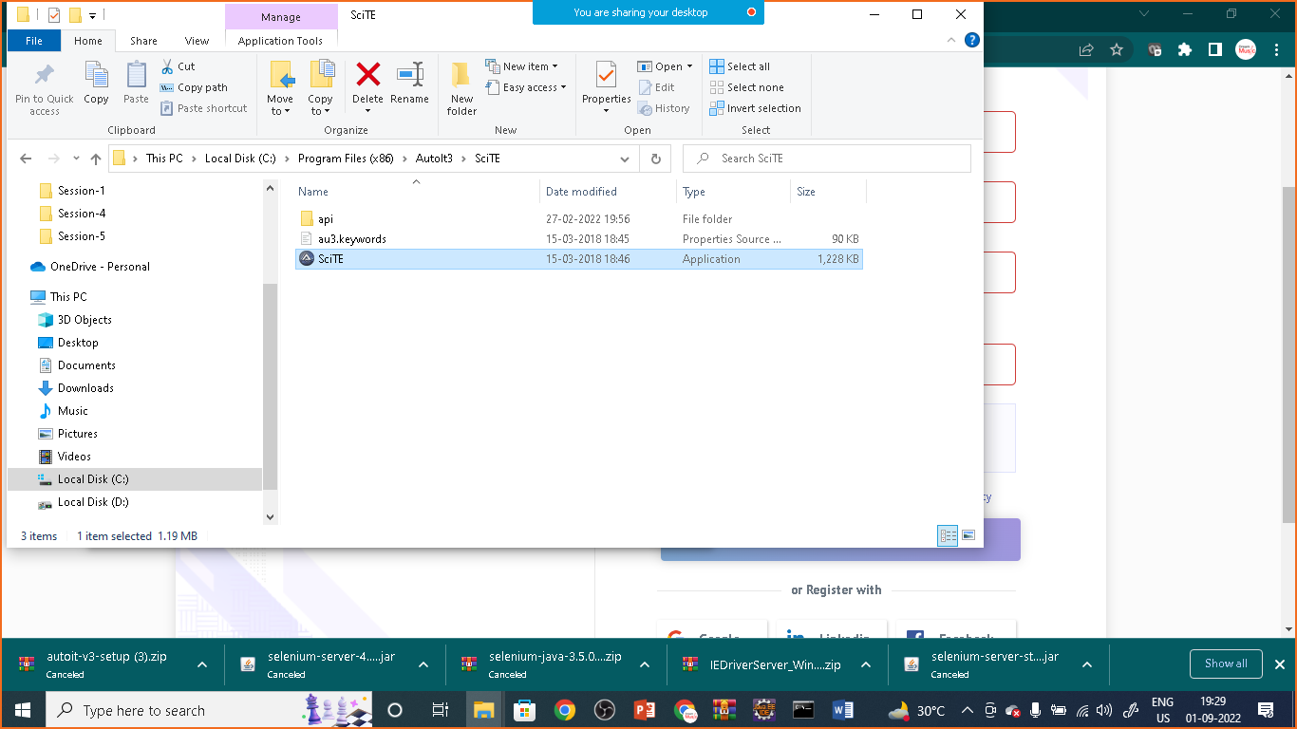

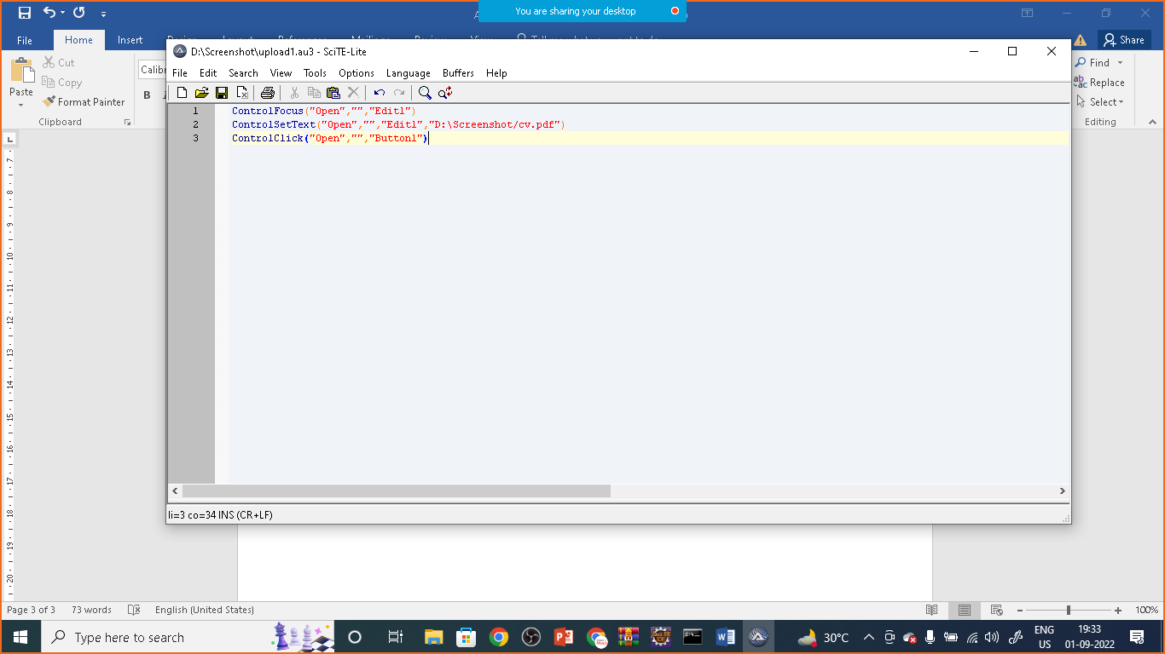

Code:

ControlFocus("Open","","Edit1")

ControlSetText("Open","","Edit1","D:\Screenshot\cv.pdf") //change your path

ControlClick("Open","","Button1")

Save the file : upload.au3 extension in the same location where your pdf or document is saved

Now goto to the folder where you have saved the script (upload.au3) file

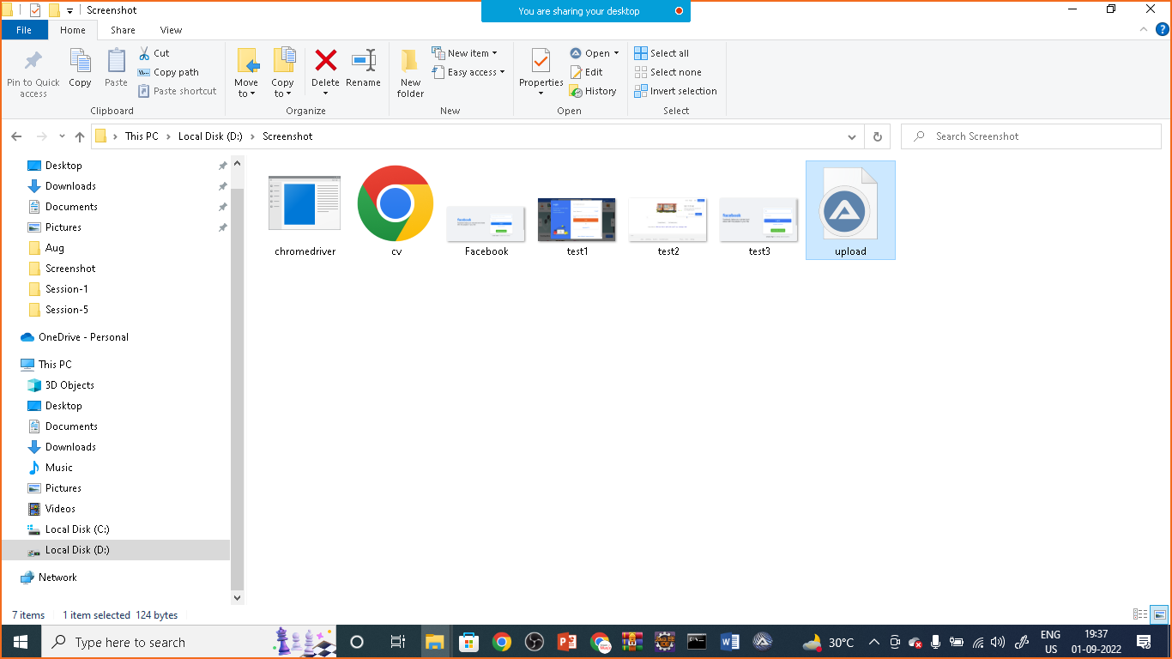

Right click on it and choose compile script

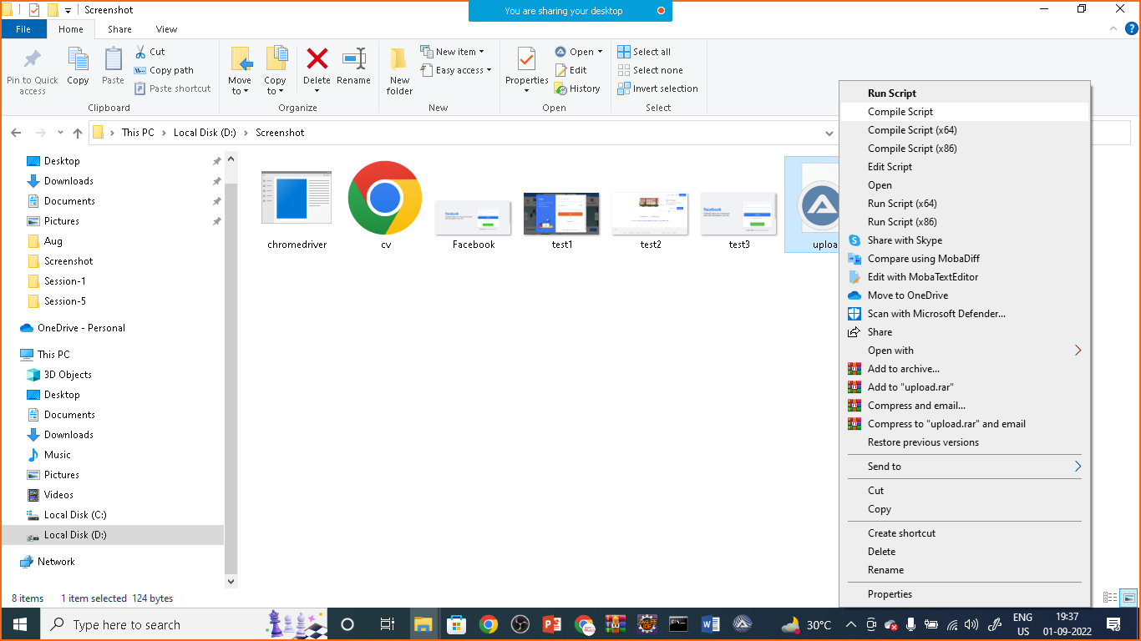

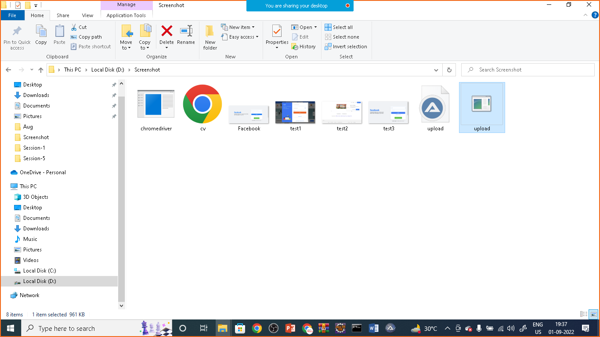

Now it will prepare Upload.exe file

Now we can prepare one java program ion eclips to run this script and automate webpage along with window GUI

AutoIt.java

**package** com.simplielearn.demo;

**import** java.io.IOException;

**import** org.openqa.selenium.By;

**import** org.openqa.selenium.JavascriptExecutor;

**import** org.openqa.selenium.WebDriver;

**import** org.openqa.selenium.WebElement;

**import** org.openqa.selenium.chrome.ChromeDriver;

**public** **class** AutoIt {

**public** **static** **void** main(String[] args) **throws** IOException,InterruptedException {

System.*setProperty*("webdriver.chrome.driver", "D:\\Phase-5\\chromedriver_win32_Sept\\chromedriver.exe");

WebDriver driver= **new** ChromeDriver();

driver.manage().window().maximize();

driver.get("https://www.shine.com/register/general/");

WebElement name= driver.findElement(By.*id*("id_name"));

name.sendKeys("Nikunj Soni");

WebElement email= driver.findElement(By.*id*("id_email"));

email.sendKeys("Nikunj@gmail.com");

///file upload

WebElement element= driver.findElement(By.*id*("id_file"));

JavascriptExecutor executor = (JavascriptExecutor)driver;

executor.executeScript("arguments[0].click()", element);

Thread.*sleep*(5000);

Runtime.*getRuntime*().exec("D:\\Screenshot\\upload.exe");

}

}

Right click and run as java application

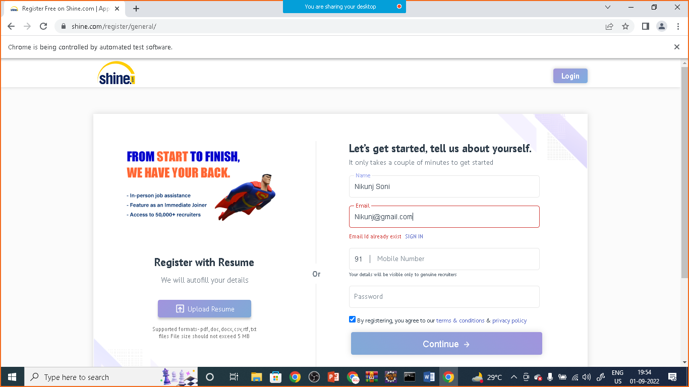

cv.pdf is uploaded successfully after wait time of 5 seconds